AHMED YUSUF PATEL 27342514  
  
ARNO PRETORIUS  
26056569

MATH TUTORING EXPERT SYSTEM USER MANUAL

Contents

Getting Started 2

System Requirements 2

Installing the system 3

Using the system 4

# Getting Started

The math tutoring expert system can be used for young learners aged 5 – 10 to allow them to exercise their mathematical skills. Problems such as addition, subtraction, division and multiplication forms the main part of the expert system. It allows the young learner to specify the length of numbered problems that they want to solve (for example, if they select a length of 3 numbers and the addition operator, then a sum like 2 + 5 + 7 will be shown). It will allow the young learner to specify the number of questions and difficulty that they want to practice as well. After the user has started the mathematical problems, he/she has the option to complete the questions or to go back and select new options.

# System Requirements

|  |  |
| --- | --- |
| OS | Windows 10, Windows 8.1, Windows 8, Windows 7 |
| Computer | PC with one of the above OS preinstalled (Upgraded machines not supported).  *.NET Framework 4.5 or later is required. |
| CPU | 1.3GHz core 2 Quad processor or later |
| RAM | Minimum: 512MB  Recommended: 1GB |
| Display | Screen resolution: 1024 x 768 pixels or more  Color quality: Medium (16 bit or more) |
| Additional requirements | .Net Framework |

# Installing the system

1. Install the .Net Framework file located in the “Additional Software” folder.
2. Once installation is complete, navigate to the GUI version -> itrw-313-es -> MathTutoringExpertSystem -> bin -> Debug.
3. Click the MathTutoringExpertSystem.exe file to start the program as shown below and wait a few seconds for it to start up.

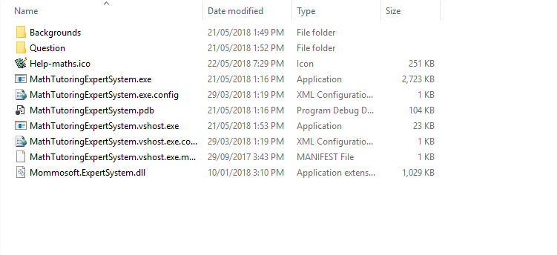

1. Enjoy the program.

# Using the system

1. When the program starts up, it will look as shown below

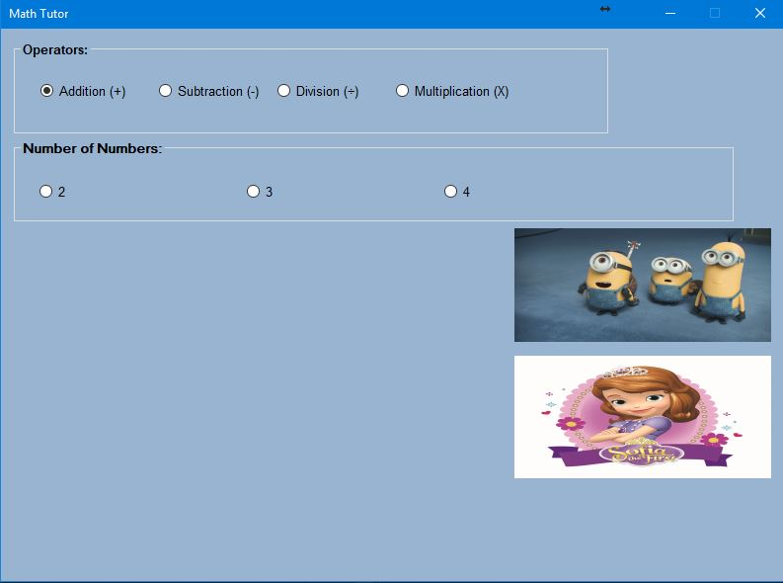

1. Select the desired operator, the number of numbers that you want to work with, the number of questions and the difficulty as shown below. Click “proceed” to continue.

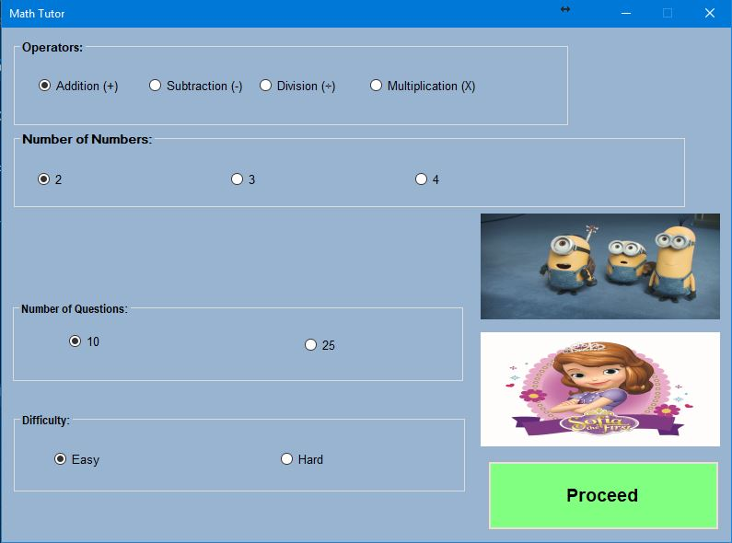

1. The Form containing the questions is opened up as shown below. The “Help” button gives basic instructions on how to use the program (refer to step 4), the “Back” button allows you to go back to the main form (home page). The “Next” button shows the questions.

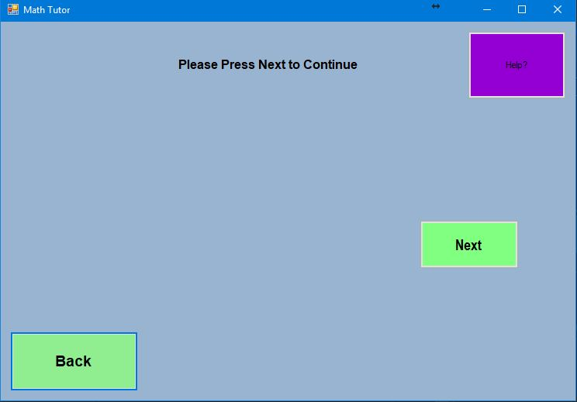

1. The Help button shows the user some basic instructions for using the program. Click the “X” on the top right to close the Help form.

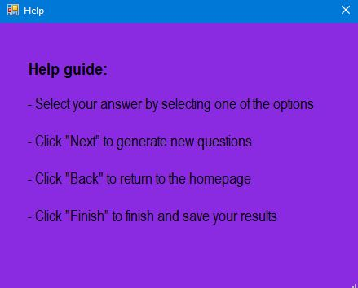

1. Pressing the “Next” button in step 3 shows the question numbers, the question and the possible answers as shown below.

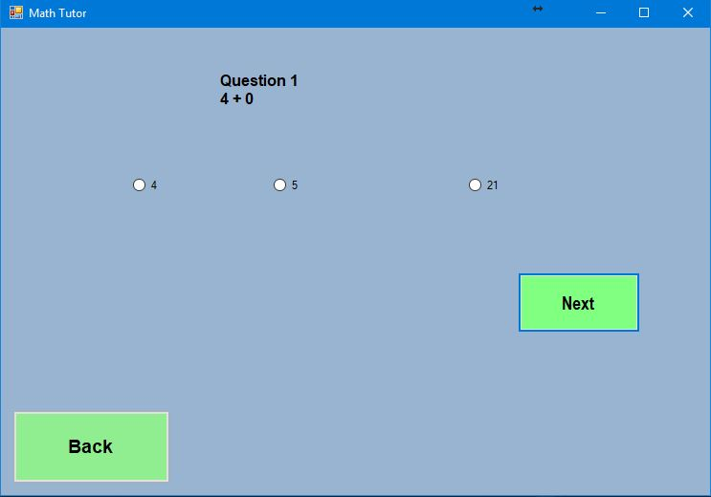

1. After Selecting a possible answer, the system indicates whether you are correct or incorrect and shows you both the question and the answer as shown below.

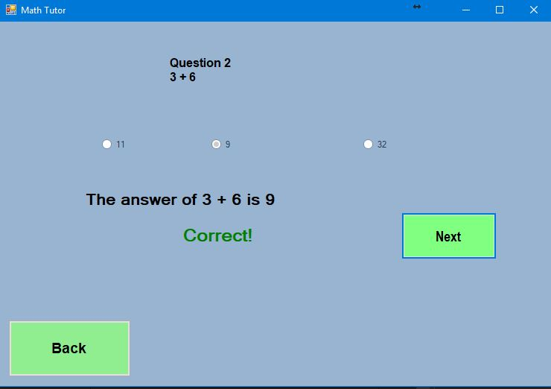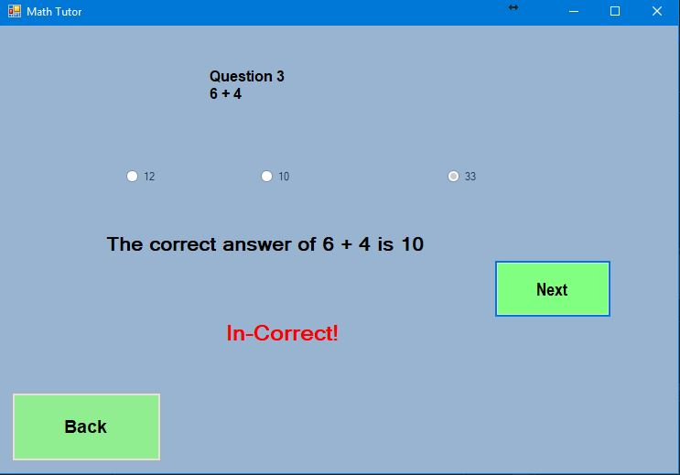

1. When you have reached the End, the “Next” button gives you an indication of your score and disappears. The “Back” button also disappears. The “Finish” button appears along with instructions indicating what to do.

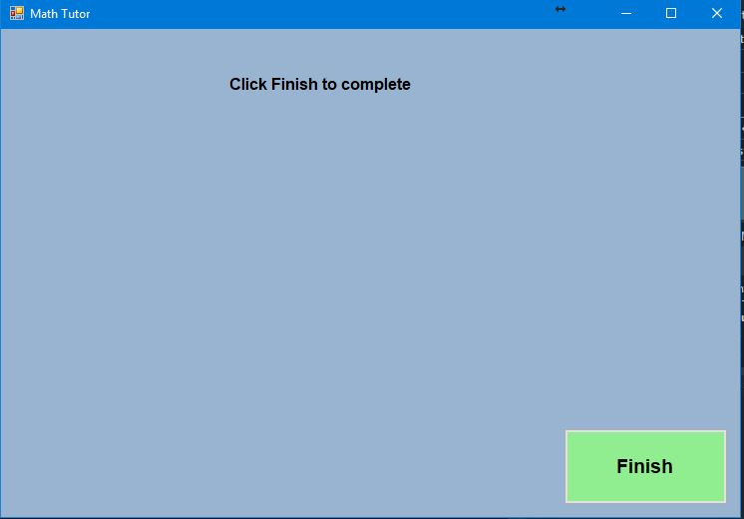

1. When the Finish button is clicked, a score is given once again and it offers you a choice to replay or to exit as shown below. If “Yes” is clicked then it restarts it again with different questions, if “No” is clicked then it exits the program.

